“Why Do Stock Prices Move So Chaotically?”

Before swooping in the science of stock market price fluctuations, the dos and don’ts of stock investing, let us understand what are stocks.
A STOCK can also be referred to as a share, and it is a share in the ownership of an organization.
Suppose a company’s valuation is at 100crore and the company wants the funding of 50 crores to expand.
Now there are two options for the company, it can either find an investor who would invest 50 Crores in the firm or the firm can make its shares public.
What it means is, the company divides its valuation in multiple parts and sell it to the public for example, company sells 1 crore shares @Rs.50 per share, this transaction would get them the investment of 50crores.
By Owning stock, you can benefit when the company becomes profitable because it allows you to make a claim on the overall earnings of an organization.
Now how do you profit from the stocks? Let’s understand this.
There are three main ways:
- Selling shares at higher price: selling a share purchased at a price of Rs. 50 and selling it at Rs. 80, the difference is the profit.
- Dividend: Every quarter the company declares its profit & loss, from the profit the company may announce dividend to its shareholders. Reinvesting the dividend can enhance your overall returns over time.
- Bonus Shares: shareholders may receive additional shares based on their current holding.

STOCK MARKET
The market is regulated by the Securities and Exchange Board of India (SEBI), which ensures transparency and investor protection.
It is basically a market established for buying and selling of stocks, where publicly listed companies trade their shares.
Major Stock Exchanges in India are: NSE, BSE, MCX, NCDEX, India INX

You place an order (e.g., Buy 10 shares of Reliance) on your broker’s app.
Your broker sends the order to the stock exchange (NSE or BSE).
The exchange’s order-matching system looks for a seller at the price you want. When a match is found, the trade is executed instantly. The shares are taken from the seller’s demat account and sent to your demat account.
Money is deducted from your trading account and sent to the seller.
We often hear on the news or online that the stock market has gone up or down. This simply means that the overall performance of the many public companies listed on the stock exchanges has improved or declined collectively.
To list the stock price Stock Exchange uses algorithms based on the current stock price and the traded volume.
- Supply and demand: The price of a stock is determined by the balance between buyers (demand) and sellers (supply). When demand is higher than supply, the price goes up; when supply is higher than demand, the price goes down.
- Electronic order matching: In India, the National Stock Exchange and Bombay Stock Exchange use an electronic system where algorithms match buy and sell orders to determine the current trading price.
- Last Traded Price (LTP): LTP is the price at which the most recent trade happened for a stock. If someone buys or sells even 1 share, the price of that trade becomes the new LTP. Because trades happen continuously during market hours, LTP keeps updating in real time.
Example:
- Buyer places order: ₹210
- Seller places order: ₹210
Trade executes → LTP = ₹210
This becomes the real-time visible price.
Five seconds later:
- Another trade happens at ₹213
New LTP = ₹213
This LTP is what you see listed on the stock market screen.

How do we measure the performance of the stock market?
A stock market index is a measurement that tracks the performance of a group of selected stocks. It shows whether the overall stock market is going up or down.
These selected stocks usually represent the largest, most important, or most traded companies. Investors use it to understand market trends, compare returns, and make investment decisions.
SENSEX & NIFTY50 are the stock market indices in India.
Sensex: BSE (Bombay Stock Exchange)
Number of Companies listed are the 30 largest and most actively traded companies.
Tracks the performance of 30 top companies from different sectors like transportation, technology etc.
Some of the listed companies are:
Reliance, TCS, Infosys, HDFC Bank, ICICI Bank, SBI, Bharti Airtel.
Nifty 50: NSE (National Stock Exchange)
Number of Companies are Top 50 companies
Tracks the performance of 50 major companies across various sectors and serves as a benchmark for mutual funds, ETFs, and market performance.
Example companies in Nifty 50:
HDFC Bank, Reliance, Titan, Infosys, ITC, Asian Paints, Adani Enterprises.
These indices help investors understand how the overall market is performing. Shows whether the Indian stock market is rising or falling and acts as an indicator of market sentiment and economic conditions.
Before you dive into the world of stock trading, it is crucial to have some basic education on trading.

The major trading styles include:
- Scalping,
- Day Trading,
- Swing Trading
- Position Trading each defined by how long traders hold their assets.
Scalping: A fast-paced method where traders place multiple trades within minutes or seconds, aiming to earn small profits from tiny price movements.
Day Trading: Buying and selling within the same trading day, with the goal of capturing short-term price fluctuations before the market closes. RIL recently saw a session where it “recorded a total traded volume of … 11,61,747 shares … opened at ₹1,542.3, hit an intraday high of ₹1,552.5 and a low of ₹1,540.5, and closed at ₹1,548.4 (last traded price)” on that day. Markets Mojo
Swing Trading: Holding trades for several days or weeks to take advantage of short-term market trends and price swings.
Position Trading: A long-term approach where traders hold assets for months or even years, relying on major market trends and fundamental analysis. For example, Apple Inc. has been performing well over the years and going by its historical uptrend, it is well positioned for long term growth and future investments.
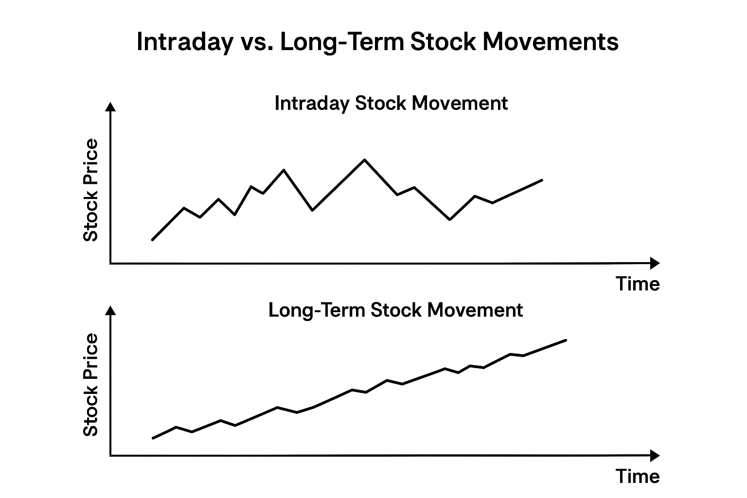
There are various factors as to why stock market moves the way they do.
- Supply and demand dynamics drive price changes
If many want to buy and few want to sell → price goes up. If many want to sell and few want to buy → price goes down. 5paisa+2The Motley Fool+2
Because there are millions of investors and traders acting at once — each with different motivations — prices can swing sharply even on small pieces of new information.
BSE Sensex / NSE Nifty 50 — broad market sell-off (Feb 28, 2025)
On that day, Sensex recorded one of its worst intraday performances of 2025, and Nifty also fell sharply. mint
The decline was driven by a wave of selling across sectors, triggered by global trade tensions and investor fears, causing many stocks to tumble heavily. mint+1
In a recent session, markets saw a sharp fall with many large-cap and small-/mid-cap stocks hit hard, causing a massive drop in overall market capitalization. The Times of India+1
The crash was reportedly triggered by a build-up of overvaluation, foreign institutional investor (FII) outflows, and broad-based profit-booking — leading many investors to sell at once. The Times of India+2sharemarket.org.in+2

- News, information, and changing expectations influence investor behaviour
Publicly available information — earnings reports, economic data, global events, company announcements — affects how investors view a company’s future prospects. This constantly shifts demand and supply, leading to rapid price changes. The Motley Fool+2nasdaq.com+2
Because news arrives unpredictably and investors react differently (some quickly, some slowly), market prices can react fast and erratically.
In April 2025, HDFC Bank shares rose more than 2% even while the broader market was weak, because the bank reported a strong quarter: growth in loans and deposits. mint
This shows how company-specific good news can trigger a short-term positive move, even if overall market sentiment is negative.

- Psychology, emotions and herd behaviour add volatility
Investor sentiment — fear, greed, panic, euphoria — often drives buying or selling far more than fundamentals. When many investors act on emotion, price swings intensify. The Motley Fool+2Forbes+2
This emotional volatility means that even if company fundamentals are stable, prices can fluctuate sharply in the short term.
On July 30, 2025, Trump announced a 25% tariff on Indian exports. On the next trading day, the Indian market opened sharply lower: Sensex and Nifty fell, reflecting negative investor sentiment. The Times of India+1
On August 7, 2025, when the U.S. doubled the tariffs — raising them to 50% on many Indian goods — Indian markets again reacted strongly. The Sensex dropped by 335.71 points at the opening, and Nifty also declined significantly. Hindustan Times+1
Analysts attributed the sharp fall to concerns that export-oriented sectors (like textiles, auto-components, jewellery, leather etc.) would suffer under the new tariffs, thereby hurting revenues and overall market sentiment. The Economic Times+2The Economic Times+2. As a result, foreign institutional investors reportedly increased selling in Indian equities, contributing to market volatility and broader bearish pressure. mint+1
- Short-term randomness vs. long-term value
In the short run, price moves may seem random, influenced by trades, sentiment, and news. Over the long run, prices tend to reflect fundamentals — company performance, earnings, growth prospects. The Motley Fool+1
Thus, what looks chaotic minute-by-minute or day-by-day may make sense over months or years.
Recently, even though the stock had some short-term declines over a few days, its long-term performance has been very strong. Markets Mojo+2Markets Mojo+2
As of late-2025, RIL(Reliance India) reported a significant rebound: driven by strong performance in its telecom, retail, and energy (oil-to-chemicals) businesses — resulting in a major increase in market value and a surge in share price. The Times of India+2The Economic Times+2
Over the long term (10 years), RIL(Reliance India) has delivered substantial returns, showing that despite short-term dips or volatility, its intrinsic business value and fundamentals have driven overall growth. Markets Mojo+2Markets Mojo+

Key Takeaways
- Stocks = Ownership: Owning a stock is owning a piece of a company.
- Three Ways to Profit: Capital gains (sell higher), dividends, and bonus shares.
- Markets Are Structured: SEBI regulates; NSE and BSE match buyers and sellers in real-time.
- Price = Supply & Demand: More buyers → prices rise; more sellers → prices fall.
- Indices Show Overall Trends: Sensex & Nifty 50 reflect market sentiment.
- Trading Styles Vary by Duration: Scalping → seconds; Day → hours; Swing → days/weeks; Position → months/years.
- Volatility Causes: News, psychology, herd behaviour, and short-term randomness.
- Look Long-Term: Short-term chaos often smooths out; fundamentals drive long-term returns.
- Stay Calm & Analytical: Avoid emotional trading; analyse trends, fundamentals, and company health.
- Stay Invested With the Buy and Hold Strategy
- Explore New Industries. Diversification is vital for reducing risks and enhancing returns
Along with the rise in investments in listed shares, the unlisted markets also attracted attention. Unlisted shares come with major hurdles, regulatory gaps, liquidity issues, and a lack of transparency, that make them far more dangerous than rewarding.
BEWARE! of the unlisted shares and conduct thorough research before investing.
This is concise post of everything you need to know before investing in shares and or buying or selling stocks.

Happy Stocking!

